# React Movie App

Build a movie app, for the scope of this assignment just create 2 components:

1. MoviesList
   1. Create a MoviesList Component which will get props from App.js and will render a list of movies on the UI.
2. App.js
   1. Update/delete everything from App.js
   2. Use hard coded data(sample data is provided on next page) to set movies in the component state
   3. Import the MoviesList component and use it in App.js and pass the movies data to it.

**Notes:**

* Create a branch from master name it assignment2 (assuming you have already created the basic react app and pushed to git)
* After successfully completing the assignment with due date, create a pull request for master and add me([amina.sattar989@gmail.com](mailto:amina.sattar989@gmail.com)) as reviewer.
* You can use styling as you like, similarly you can use css, bootstrap or any other library for styling as per your choice. But just for the guidance find screenshot below to understand what is expected,

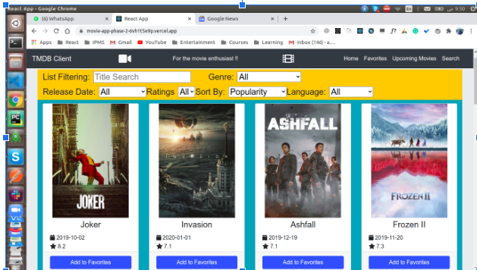

**Sample Data:**[

{

Title: 'Star Wars: Episode IV - A New Hope',

Year: '1977',

imdbID: 'tt0076759',

Type: 'movie',

Poster:

'https://m.media-amazon.com/images/M/MV5BNzVlY2MwMjktM2E4OS00Y2Y3LWE3ZjctYzhkZGM3YzA1ZWM2XkEyXkFqcGdeQXVyNzkwMjQ5NzM@._V1_SX300.jpg',

},

{

Title: 'Star Wars: Episode V - The Empire Strikes Back',

Year: '1980',

imdbID: 'tt0080684',

Type: 'movie',

Poster:

'https://m.media-amazon.com/images/M/MV5BYmU1NDRjNDgtMzhiMi00NjZmLTg5NGItZDNiZjU5NTU4OTE0XkEyXkFqcGdeQXVyNzkwMjQ5NzM@._V1_SX300.jpg',

},

{

Title: 'Star Wars: Episode VI - Return of the Jedi',

Year: '1983',

imdbID: 'tt0086190',

Type: 'movie',

Poster:

'https://m.media-amazon.com/images/M/MV5BOWZlMjFiYzgtMTUzNC00Y2IzLTk1NTMtZmNhMTczNTk0ODk1XkEyXkFqcGdeQXVyNTAyODkwOQ@@._V1_SX300.jpg',

}

]